Local Search with Candidate Moves
Students
- Patrick Molina, 157419
- Chihabeddine Zitouni, 158753

Code Repository
https://github.com/patrickmolina1/Evolutionary-Computation

Problem Description
The task is to select a subset of nodes and form an optimal Hamiltonian cycle minimizing the total cost and travel distance. Each node is defined by three attributes: x-coordinate, y-coordinate, and cost. Exactly 50% of the nodes must be selected (rounded up if the total number is odd). The goal is to minimize the sum of the cycle length and the total cost of the selected nodes. Distances between nodes are computed using the Euclidean distance, rounded to the nearest integer. A distance matrix is precomputed after reading each instance and used throughout the optimization process, allowing instances to be represented solely by distance values

Methods
- Steepest Local Search
  - Random Start + Node Exchange
  - Random Start + Edge Exchange

Computational experiment

CPU Specs
AMD Ryzen 7 5800H with Radeon Graphics
Cores | Threads | Clockspeed | Turbo Speed
8 | 16 | 3.2 GHz | 4.4 GHz

Pseudocode
Algorithm: Steepest Local Search with Candidate Moves
Input: instance, startingSolutionType, intraRouteMoveType
Output: solution
- Record startTime
- Build candidateEdges map using buildCandidateEdges(instance, NUM_CANDIDATES)
- Generate starting solution (random)
- Initialize selectedNodes, cycle, selectedIds from starting solution
- Initialize currentCost, currentDistance from starting solution
- Set improved ← true
- While improved:
- Set improved ← false
- Initialize bestDelta ← 0, bestDistanceDelta ← 0, bestMoveType ← null, bestMove ← null
- For each idx in cycle:
- Get nodeId ← cycle[idx]
- Get neighbors ← candidateEdges[nodeId]
- If neighbors is null, continue
- Calculate prevIdx, nextIdx (with wraparound)
- Get prevNodeId ← cycle[prevIdx], nextNodeId ← cycle[nextIdx]
- For each neighborId in neighbors:
    - If neighborId is selected (in selectedIds):
INTRA-route candidate move:
      - Find neighborIdx in cycle
      - Skip if nodeId and neighborId are adjacent
      - Create move ← [idx, neighborIdx]
      - Calculate delta using calculateIntraDelta
      - If delta < bestDelta: update bestDelta, bestMove, bestMoveType ← "INTRA"
    - Else (neighborId not selected):
INTER-route candidate move:
      - Calculate delta1 ← calculateInterDeltaDetailed for exchange (prevNodeId, neighborId)
      - If delta1.totalDelta < bestDelta: update bestDelta, bestDistanceDelta, bestMove ← [prevNodeId, neighborId], bestMoveType ← "INTER"
      - Calculate delta2 ← calculateInterDeltaDetailed for exchange (nextNodeId, neighborId)
      - If delta2.totalDelta < bestDelta: update bestDelta, bestDistanceDelta, bestMove ← [nextNodeId, neighborId], bestMoveType ← "INTER"
- If bestDelta < 0 AND bestMoveType ≠ null:
- Set improved ← true
- If bestMoveType equals "INTRA":
    - Apply applyIntraMove(cycle, bestMove, intraRouteMoveType)
    - Update currentDistance += bestDelt
    - Update currentCost += bestDelta
- Else (bestMoveType equals "INTER"):
    - Extract selectedNodeId ← bestMove[0], nonSelectedNodeId ← bestMove[1]
    - Apply applyInterMove with selectedNodeId and nonSelectedNodeId
    - Update currentDistance += bestDistanceDelta
    - Update currentCost += bestDelta
- Record endTime
- Return solution with final selectedNodes, cycle, currentCost, currentDistance, execution time

Algorithm: Build Candidate Edges
Input: instance, k (number of candidates)
Output: candidateEdges map
- Initialize candidateEdges ← empty map
- Get n ← instance.nodes.size()
- For each node in instance.nodes:
- Get id ← node.id
- Initialize neighbors ← empty list
- For each other in instance.nodes:
- If node.id equals other.id, continue
- Calculate metric ← distanceMatrix[node.id][other.id] + other.cost
- Add [other.id, metric] to neighbors
- Sort neighbors by metric (ascending)
- Initialize nearest ← empty set
- For i from 0 to min(k, neighbors.size()):
- Add neighbors[i][0] to nearest
- Put (id, nearest) into candidateEdges
- Return candidateEdges

Results
Method | Instance A | Instance B
SteepestLS Candidate Node Exchange | 98503.65 (89161 - 109877) | 67747.81 (58473 - 79217)
SteepestLS Candidate Edge Exchange | 77686.81 (73167 - 81696) | 48517.50 (46027 - 52483)

SteepestLS Node Exchange | 88108.59 (79789 - 97542) | 62995.08 (55969 - 71020)
SteepestLS Edge Exchange | 74038.50 (71587 - 77720) | 48372.30 (45719 - 51098)

Running Times(ms)

Method | Instance A | Instance B
SteepestLS Candidate Node Exchange | 16.98 (13 - 85) | 20.24 (16 - 99)
SteepestLS Candidate Edge Exchange | 15.73 (13 - 22) | 19.97 (17 - 28)

SteepestLS Node Exchange | 257.92 (190 - 419) | 266.45 (183 - 425)
SteepestLS Edge Exchange | 222.91 (177 - 347) | 228.37 (176 - 376)

Best Solution

Instance A

Steepest LS Candidate Node Exchange
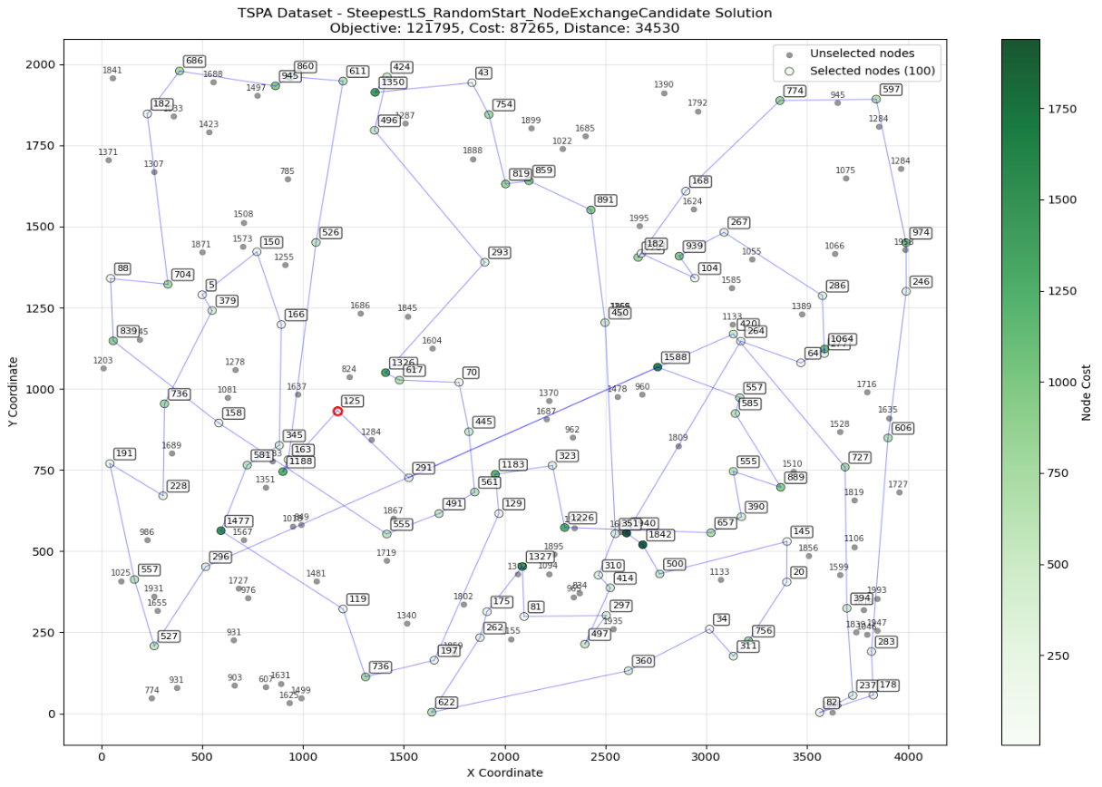

Steepest LS Candidate Edge Exchange

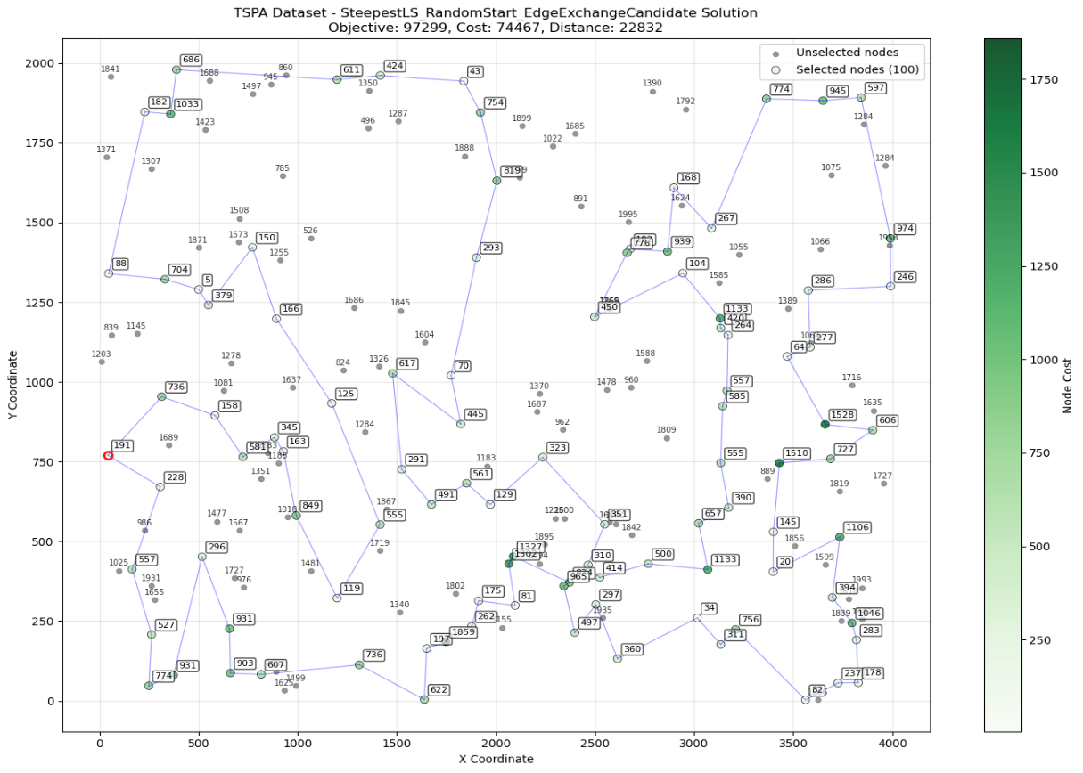

Steepest LS Node Exchange
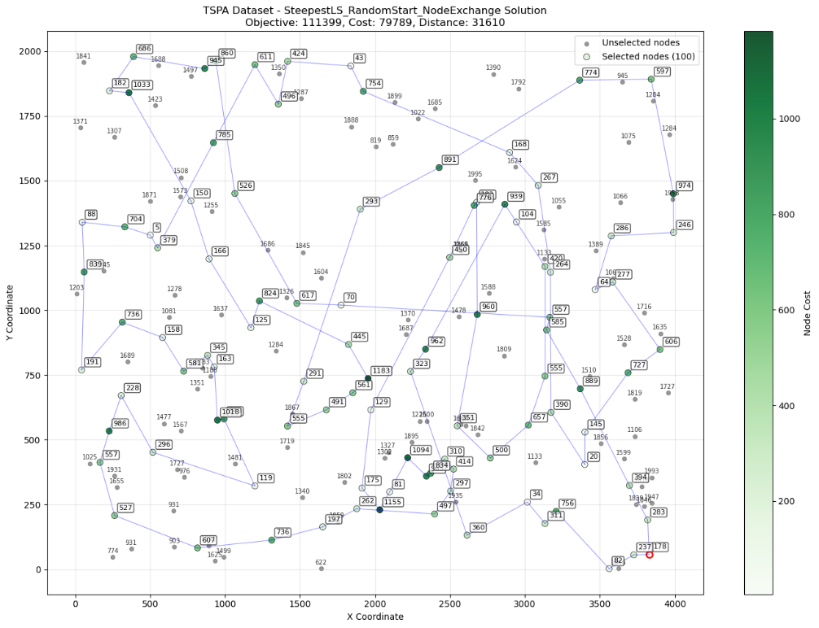

Steepest LS Edge Exchange
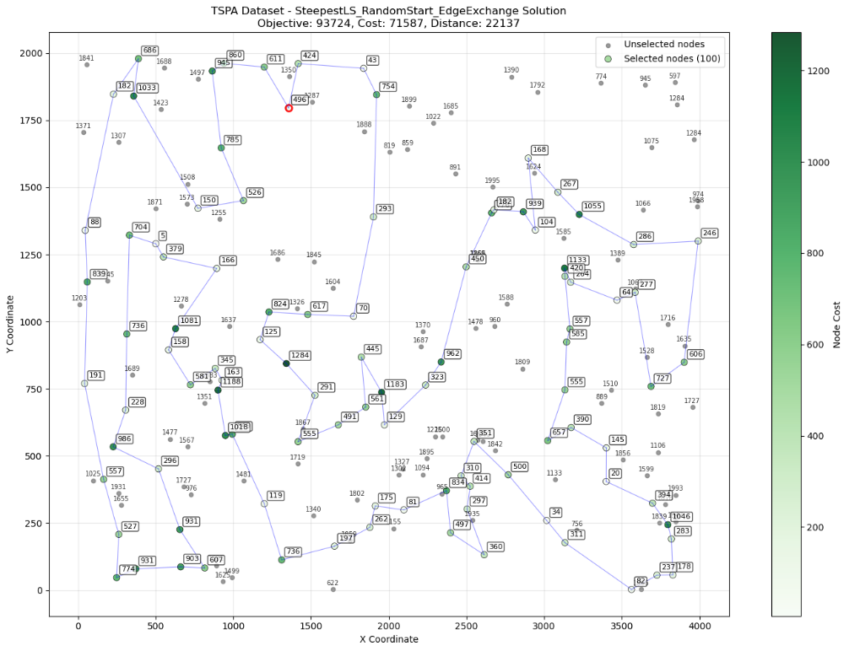

Instance B

Steepest LS Candidate Node Exchange
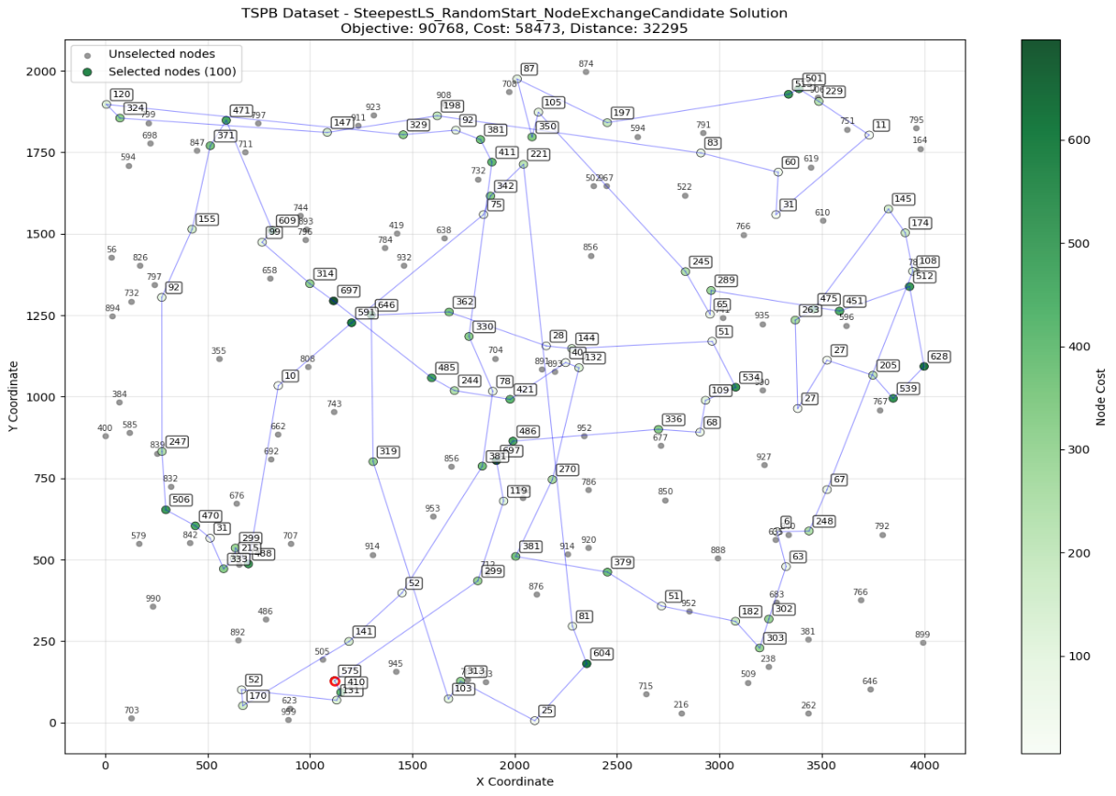

Steepest LS Candidate Edge Exchange

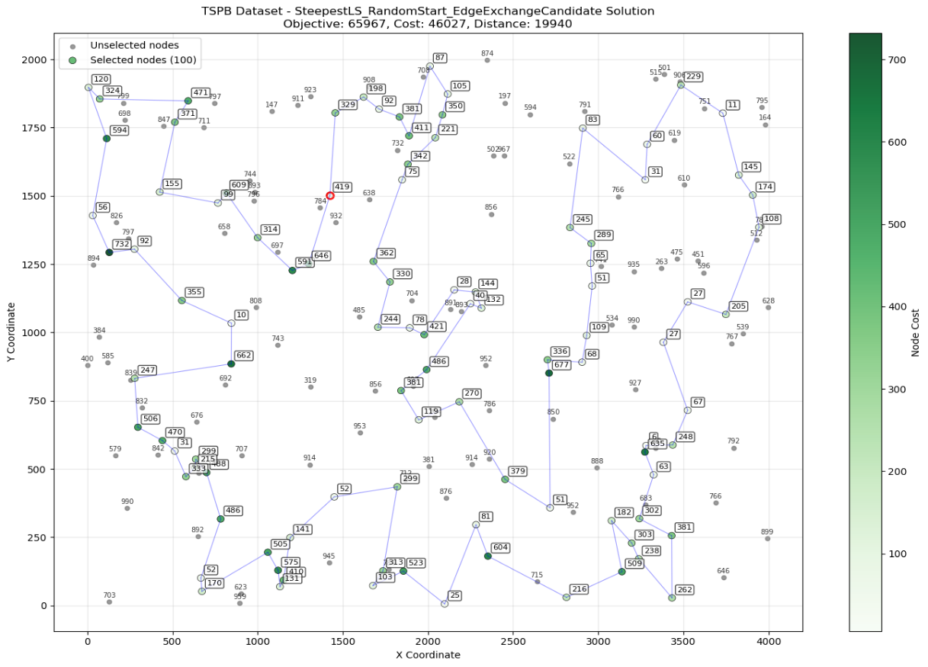

Steepest LS Node Exchange
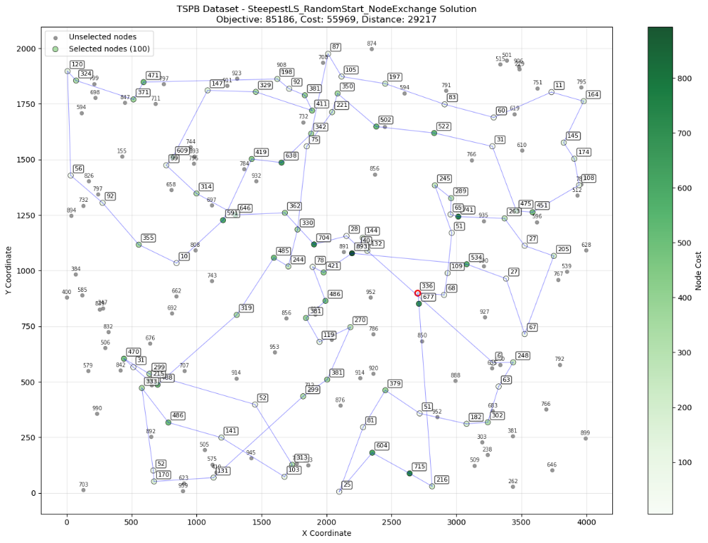

Steepest LS Edge Exchange
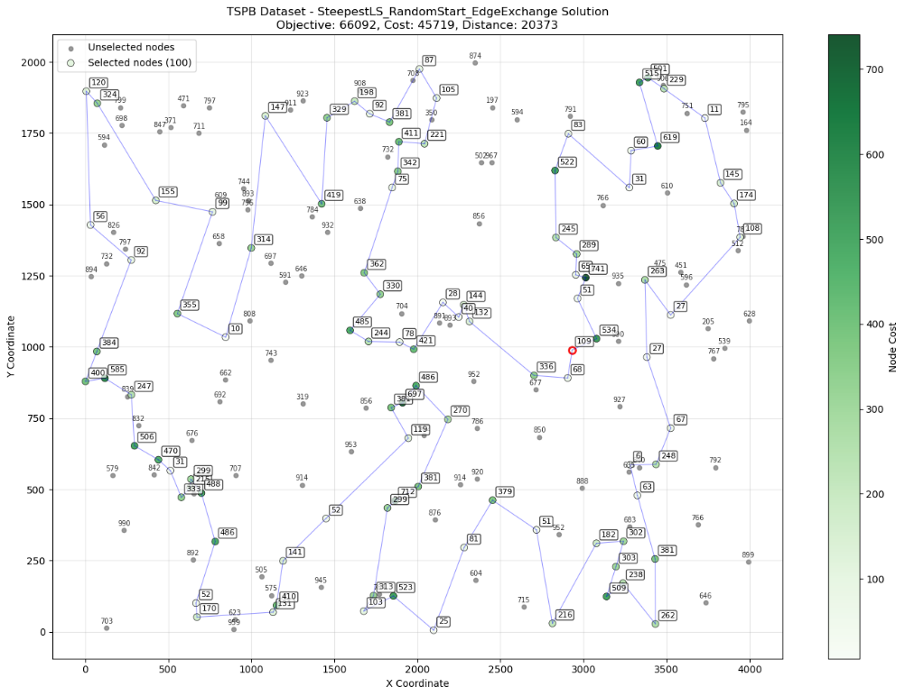

Cycles

Instance A

Steepest LS Candidate Node Exchange
143-117-0-46-139-193-41-115-59-162-123-43-181-34-42-116-65-151-133-79-63-127-11-184-35-160-54-177-10-4-112-70-44-16-171-175-113-56-31-78-145-129-2-1-152-125-52-165-90-164-21-14-119-40-185-91-25-120-82-92-57-55-106-178-49-155-144-89-183-23-137-68-18-22-146-159-51-176-80-122-121-99-19-97-26-101-75-86-154-135-180-53-94-12-148-9-62-15-108-69

Steepest LS Candidate Edge Exchange
122-79-80-176-137-23-186-89-183-143-0-117-93-108-18-22-146-34-160-54-177-10-190-4-112-184-131-149-65-116-43-42-5-41-193-159-191-139-68-46-198-115-59-51-151-133-162-123-127-135-154-180-158-53-182-121-26-97-1-101-86-75-2-152-167-52-55-57-92-129-82-120-44-16-171-175-113-56-31-78-145-157-196-81-90-165-40-185-106-178-49-14-144-62-9-15-148-124-94-63

Instance B

Steepest LS Candidate Node Exchange
142-21-8-56-144-143-106-124-128-62-109-29-139-74-25-36-61-141-97-77-145-195-168-118-121-73-54-31-193-117-198-156-1-135-122-133-10-191-90-51-98-182-138-160-0-35-111-82-81-153-163-89-103-113-176-194-166-94-47-148-130-95-86-185-179-172-57-66-99-55-18-34-3-15-70-155-4-149-28-20-183-140-152-188-147-107-40-6-169-132-13-11-33-104-177-5-80-190-175-78

Steepest LS Candidate Edge Exchange
134-6-188-169-132-13-70-3-15-145-195-168-139-11-138-33-160-29-109-35-0-144-104-8-111-81-153-159-143-106-124-62-18-55-34-152-183-140-28-20-148-47-94-179-185-86-166-194-176-180-113-103-114-137-127-89-163-165-187-97-77-141-91-36-61-21-177-5-78-175-142-45-80-190-136-73-54-31-193-117-198-156-1-112-121-131-135-102-63-100-40-107-10-133-122-90-191-51-118-74

Conclusion
- The implementation of candidate move strategies represents a significant advancement in computational efficiency for steepest local search algorithms applied to the TSP variant with node selection costs. Testing both Node Exchange and Edge Exchange with Candidate Moves in both instances demonstrates that intelligent move filtering can maintain the solution quality of exhaustive local search while achieving substantial computational speedups.
- The results reveal that Edge Exchange with Candidate Moves typically produces superior solutions compared to Node Exchange with Candidate Moves, consistent with findings from previous assignments regarding neighborhood effectiveness. However, the critical achievement lies in the dramatic reduction of execution time while maintaining competitive solution quality relative to full neighborhood exploration.
- The requirement that moves must introduce at least one candidate edge prevents trivial exchanges while ensuring that the search explores meaningful modifications to the solution structure demonstrates that intelligent neighborhood restriction can achieve near-optimal solution quality at a fraction of the computational cost.

